**Index Rebuilding Run book**

**Background:**

Index Rebuilding is a tool that allows you to build a group in the background on the Rebuilding servers. This tool can be executed in parallel while Merge and Search services continuing for that group.

**Location of Tool:**

**\\JHN01CAVIDX01\LOMA_Apps\Utilities\IndexRebuilder**

**How to use this Tool:**

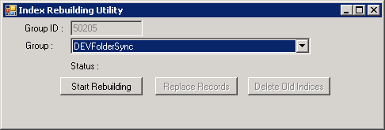

1. Make sure the SQL connection string user name and password in the config have full access rights for

Searchindexing DB , MailsToIndex table

SearchIndexingRebuilding DB MailsToIndex table.

Search DB , searchindex table.

The tool will delete, insert and update

1. Choose your group
2. Click Start Rebuilding button on the tool, at that point of time if the group has any index in process and locked by other tool it will wait till these indexes released. This can be checked from logs. Below is the sample provided for reference.

Sample Logs: 2014-06-19 15:03:09.003 [5] INFO - waiting locked indexes in queue...

1. Once the indexes get released the tool will build the ranges in searchindexingRebuilding DB, excluding the expired mails from RetentionBatchMail table. Once ranges are created Reindexing/Remerge will start to pick the items.

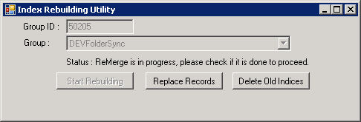

1. Once the tool has built the ranges, other two buttons (Replace Records and Delete Old Indices) will be activated. Once the ranges are created log will have below entry :

2014-06-19 15:06:30.160 [5] INFO - # Building Ranges finished.

2014-06-19 15:06:30.165 [1] INFO - ReMerge is in progress, please check if it is done to proceed , for GroupID : 50205

1. Make sure there are no Errors in the log.
2. Verify SearchindexingRebuiding..mailstoindex table to ensure all batches are in Step =4.

If there is any failed item you need to reset them back. Once you are satisfied with the Rebuilding results, click “**Replace Records**” button. This step will remove items from SearchIndexing..MailsToIndex; which are less than or equal to max endmailid range in SearchIndexingRebuilding..MailsToindex database and replace current ranges in SearchIndexingRebuilding..MailsToindex to SearchIndexing..MailsToIndex.

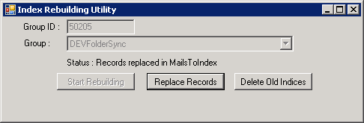

1. Click “**Delete Old Indices**” button. You will notice that Remerge created L3 indexes of type 3 and as Rebuilding finished we need to Deactivate locked indices by Index Rebuilding , Activate the type 3 indexes to be type 2 (at that point it will become searchable).

Then deleting all the DeActivated indices physical files , after that it will delete the records.

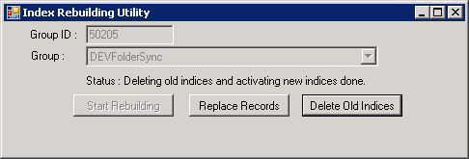

At that point you group had been rebuild successfully

**Note:**

1. This tool can’t run on the Group that had billion flip concept meaning the group have multiple mails ranges to be able to expand to more than 1 billion.
2. If you close the tool while Remerge is happening, you need to execute manual steps to finalize rebuilding the group.

**Manual Steps:**

1. After all your items in SearchIndexingRebuilding..MailsToindex in step 4
2. To move the records from SearchIndexingRebuilding..MailsToindex to SearchIndexing.MailsToindex
3. **Execute this script to clean up the items**

SearchIndexingRebuilding..MailsToindex

exec Stp_MailsToIndex_MaxIndexedMailID @GroupID

Copy the max mail id result @maxMailIDResult

go to :

SearchIndexing DB

Execute this script

EXEC Stp_MailsToIndex_DeleteRemergedRanges @LastMailID,@GroupID

1. **Execute this script to move the items**

Now go to :

SearchIndexingRebuilding DB

EXEC Stp_MailsToIndex_InsertRemergedRanges @GroupID

This will copy the records from SearchIndexingRebuilding..MailsToindex to SearchIndexing.MailsToindex

1. To DeActivate / Activate L3 indices :
   1. DeActivate L3 Rebuilded indices

On Search DB

Execute this

DECLARE @AppType tinyint=5 -- 5 mean IndexRebuilding apptype

DECLARE @GroupID int =50205

EXEC Stp_SearchIndex_DeActivateRebuildedIndexes @AppType,@GroupID

* 1. Activate L3 Rebuilded indices

DECLARE @GroupID int =50205

EXEC Stp_SearchIndex_ActivateReMergedIndexes @GroupID

* 1. Wait 1 minute
  2. Delete the physical files

DECLARE @AppType tinyint=5 -- 5 mean IndexRebuilding apptype

DECLARE @GroupID int =50205

SELECT * from searchindex (NOLOCK)

WHERE groupnum = @GroupID

AND IsLocked=1 and AppType=@AppType

For each index path delete the content

e- Delete the unused records

DECLARE @AppType tinyint=5 -- 5 mean IndexRebuilding apptype

DECLARE @GroupID int =50205

EXEC Stp_SearchIndex_DeleteRebuildedIndexes @AppType,@GroupID